**# Discrete**

**## Sine**

***//SINE SIGNAL***

**N = 100**

**t2=0:0.1:10;**

**x2=sin (t2);**

**subplot (2, 2, 1)**

**plot2d3 (t2,x2);**

**xlabel('Time');**

**ylabel('Amplitude');**

**title('Discrete Sine');**

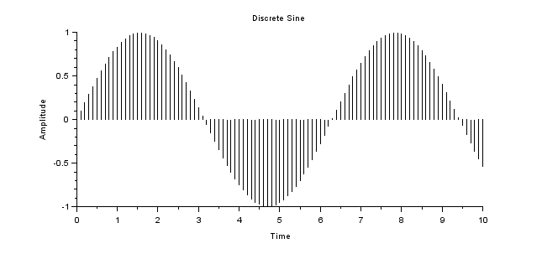

**## Rectangular**

***//RECT SIGNAL***

**N = 100**

**t2=-10:0.1:10;**

**x2=[zeros(1,(N/2)), ones(1,N+1), zeros(1,(N/2))];**

**subplot (2, 2, 2)**

**plot2d3 (t2,x2);**

**xlabel('Time');**

**ylabel('Amplitude');**

**title('Discrete Rectangular');**

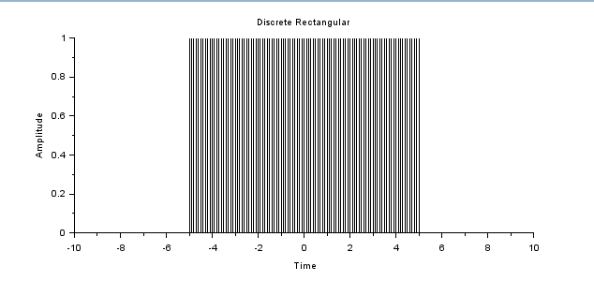

**## Ramp**

**N = 100**

**t2=0:0.1:10;**

**x2=t2;**

**subplot (2, 2, 1)**

**plot2d3 (t2,x2);**

**xlabel('Time');**

**ylabel('Amplitude');**

**title('Discrete Unit Ramp');**

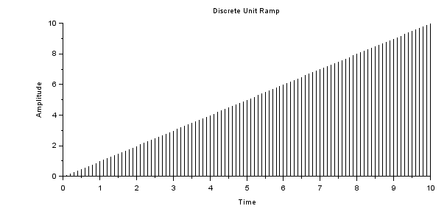

**## Exponential**

**N = 100**

**t2=-10:0.1:10;**

**x2=exp(-t2);**

**subplot (2, 2, 2)**

**plot2d3 (t2,x2);**

**xlabel('Time');**

**ylabel('Amplitude');**

**title('Discrete Expo');**

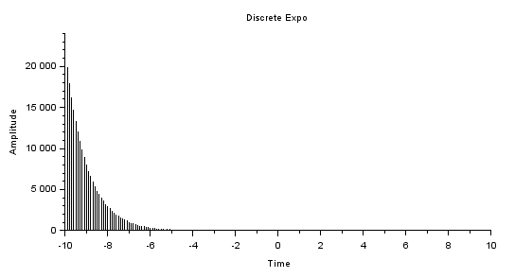

**## Step**

**N = 100**

**t2=-10:0.1:10;**

**x2=[zeros(1,N), ones(1,N+1)];**

**subplot (2, 2, 1)**

**plot2d3 (t2,x2);**

**xlabel('Time');**

**ylabel('Amplitude');**

**title('Discrete Unit Step');**

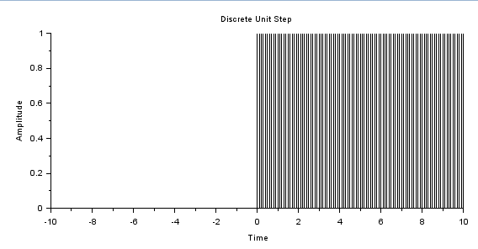

**## Impulse**

**N = 100**

**t2=-10:0.1:10;**

**x2=[zeros(1,N), 1, zeros(1,N)];**

**subplot (2, 2, 2)**

**plot2d3 (t2,x2);**

**xlabel('Time');**

**ylabel('Amplitude');**

**title('Discrete Unit Impulse');**

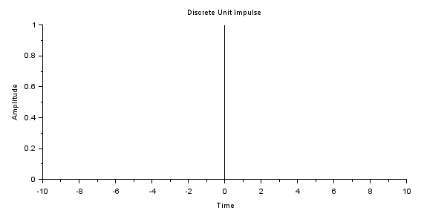

**# Random**

**N = 100**

**t2=-10:0.1:10**

**x2=rand(1,201)**

**subplot (2, 2, 1)**

**plot2d3 (t2,x2);**

**xlabel('Time');**

**ylabel('Amplitude');**

**title('Discrete Random');**

